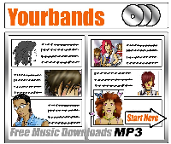

Yourbands download chart

Activity: Copy and paste the table below into a new spreadsheet document.

Yourbands download chart

Band name | Single name | No. of downloads last week | No. of downloads this week
The Bone Scrapers | Serious Fun | 75 | 50
The Fabuloso Sisters | Scream if you wanna go faster | 380 | 350
Metalmonkey | Chained Melody | 370 | 300
The Shakes | Shake ‘em up | 150 | 325
Blistercreep | Headcase | 150 | 290
Shark Girls | Pretty in Purple | 300 | 330
The Creeps | I’m in love (with myself) | 40 | 100
Rumblefish | How cool is she? | 75 | 120
Moonjuicer | Rocket Science | 200 | 175
M and M | Baby give it back | 170 | 180

